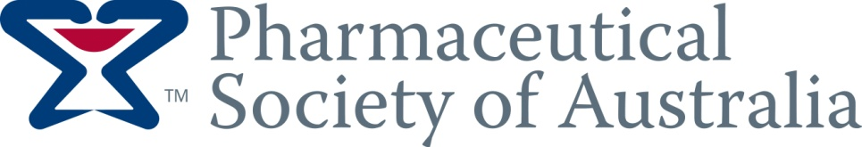

Self Care
Training Module 12:

Self Help

Module 12 Self Help

ANTIBIOTICS:

Q1. What are antibiotics used for and why is it important that antibiotics are prescribed and used appropriately?
Antibiotics are used to treat bacterial infections. Frequent and unnecessary use of antibiotics increases the development of bacteria that are resistant to antibiotics.

Q2. List two simple things that can be done to reduce the threat of antibiotic resistance.
Do not pressure your doctor to prescribe antibiotics
Take antibiotics exactly as prescribed
Never share antibiotics with family or friends
Do not use antibiotics left over from a previous infection

ALCOHOL:

Q1. What do the ‘Australian Guidelines TO REDUCE HEALTH RISKS from Drinking Alcohol?
Advises on levels of alcohol consumption that will reduce the risks of alcohol related accidents, injuries, diseases and death.

Q2. List three things that put people at higher risk of harm due to alcohol.
Under 25 and over 60 years of age
Being underweight
A family history of alcohol dependence
Certain medical conditions
Certain medicines, including complementary medicines
Use of illegal drugs

COMPLEMENTARY MEDICINES:

Q1. What medicines are referred to as ‘complementary’ medicines?
Traditional, herbal and natural medicines and remedies are referred to as a ‘complementary and alternative medicines’.

Q2. When should you refer to a pharmacist or doctor?
If using any other medicine either prescribed or over the counter

FIRST AID IN THE HOME:

Q1. When should the St John’s DRABC action plan be used?
When you are assessing if an injured person has any life threatening conditions and if immediate first aid is needed.

Q2. What does DRABC stand for?
D – check for Danger, R – check Response, A – check Airway, B – check for Breathing, C – give CPR, D – apply a Defibrillator (if available)
Q3. What first aid should be done for burns and scalds?
Remove the person from danger
Cool burnt area with cold running water for at least 20 minutes
Remove clothing and jewelry from burnt area, unless stuck to burn
Place sterile, non stick dressing over burn

Q4. What first aid treatment should be done for minor cuts and grazes?
Clean the wound thoroughly with clean (preferably sterile) water or saline solution
Apply a sterile dressing
Seek medical advice if appropriate

GENERIC MEDICINES:

Q1. What is a ‘generic’ medicine?
An alternative, often less expensive brandsof medicine. They contain the same active ingredient as the originally marketed brand and are expected to be just as safe and effective.

Q2. What characteristics of a generic medicine might be different to the actual branded medicine?
The inactive ingredients, which can include, colourings, flavourings, preservatives, fillers and special tablet coatings. They may taste different and have different packaging.

HELP WITH MEDICINE COSTS:

Q1. What is the P.B.S?
The Pharamceutical Benefits Scheme through which the Australian Government subsidises the cost of prescription medicines.

Q2. What is the purpose of the Safety Net?

The Australian Government’s PBS Safety Net helps to limit the cost of medicines for persons and families who use a large number of prescription medicines in one calendar year.

Q3. What medicines are allowed to be included on your PBS record?
Any prescribed medicine that is subsidised and dispensed under the P.B.S

Q4. What is the ‘Safety Net 20 day rule’?
If a PBS subsidised medicine is dispensed less than 20 days after a previous supply of the same medicine, the cost of this medicines may not count towards the PBS Safety Net threshold.

